Case 1-A11-Eur-England-Oxfordshire-Hand axe-424,000-374,000 BP-Lower Paleolithic

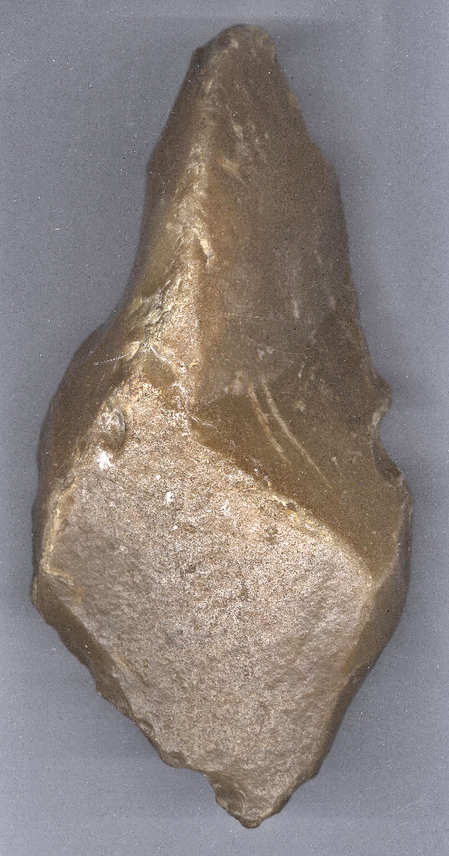 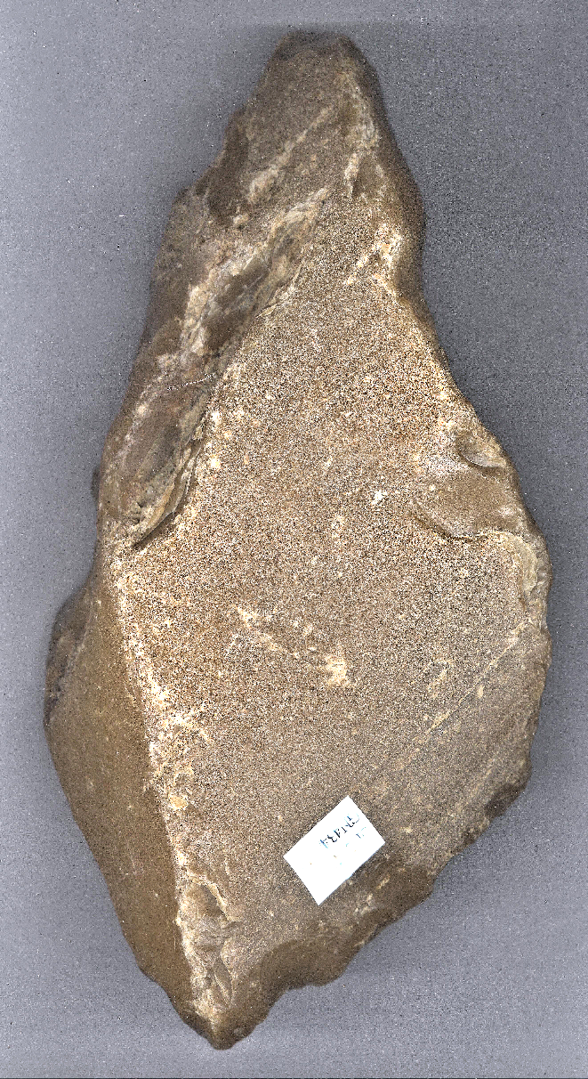

Case No.: 1

**Formal Label: Oxfordshire** flint biface hand axe of the early Hoxnian**,** 424,000-374,000 BP

**Accession Number: A 11**

**LC Classification:** GN 284

**Date or Time Horizon:** 424,000-374,000 BP

**Geographical Area:** Axe Valley gravel terrace, Vale of White Horse, Oxfordshire

|  |
| --- |
| **Map:** 51.6342334693 -1.4416666917 |

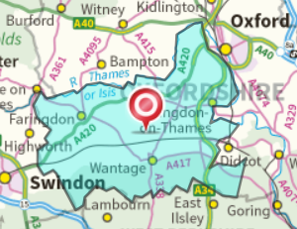

**Cultural Affiliation:** Lower Paleolithic, Hoxnian glaciation

**Medium:** Orange-brown flint with thick patina.

**Dimensions: L 18.7 cm; W 10.5 cm. Multivariate Analysis Measurements: B1/B2=60 mm; L1/L=90 mm; T1/L=60 mm; B2=80 mm; Th 50 mm. Derek Roe (**see Roe 1968a) **has selected “**three ratios B/L, B1/B2 and L1/L to construct what he termed a tripartite shape diagram to show the complete range of outline shapes present in any group of hand axes (see Roe 1968b: fig. 4). The final result of this is a series of three B1/B2 against B/L plots to cover each group of axes: one for axes with high values of L1/L (maximum width towards the point), the second for middle values of L1/L (maximum width in the middle) and the third for low values of L1/L (maximum width towards the butt [proximal] end). These have been produced by Roe (1968b: figs 5-46) for all the 38 sites” (Graham and Roe 1970: 325).

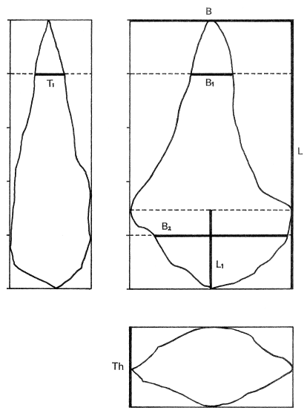

**Weight: 2.1 lbs.**

**Provenance:** This this flint biface hand axe of the early Hoxnian is **from an old Oxfordshire collection and** was recovered from a gravel pit in the 1920's from which other lithic implements were found. The deposit from which the object was recovered is situated on a terrace of the Axe Valley gravels (Sandford 1924), but the particular quarry it was discovered in (see Roe 1968a) cannot be ascertained. Green (1974) has suggested that the hand axes in the terrace gravels at sites in the Axe Valley were subjected to braided streams that were choked with chert and flint gravels where the Paleolithic knapping sites had been located. As the valley sides were subjected to solifluction and stream erosion a periglacial regime ensued. The age of these gravels is dated between the Hoxnian glaciation (which is equivalent to [Marine Isotope Stage 11](https://en.wikipedia.org/wiki/Marine_Isotopic_Stage_11)) 424,000 - 374,000 BPand the Saalian glaciation347,000 to 128,000 (McMillan 2005; Gibbard, Boreham, Cohen and Moscariello 2007). However, based on Roe’s multi-variate analysis it appears that this specimen should be assigned to the early Hoxnian, i.e., 424,000-374,000 BP.

**Condition:** Theflake edgesarein a stream-abraded condition; the ventral surface shows, what appears to be, glacial abrading.

**Discussion:** This is a complete flint biface hand axe of the early Hoxnian (ca 424,000-374,000 BP). The slightly concave cortex of the ventral surface appears to be glacially abraded. The dorsal surface has three major triangular flakes.This lithic is bi-triangular in profile with similar angles on each of the tapering distal and proximal edges. The ventral surface has invasive stepped flaking. The angular distal end, and both the left and right-hand edges contain large abrupt retouches with small retouches along most edges. The left proximal edge has a large negative ventral scar which creates the triangular shape of the proximal end. The proximal end contains some abrupt retouch as well. The flint is an orange-brown with extensive patination across the dorsal surface, and the apparently glacially abraded ventral cortex is also orange-brown in color.

**References:**

Cox, E (2013) SWYOR-CE45C4: A PALAEOLITHIC HAND AXE Web page available at: <https://finds.org.uk/database/artefacts/record/id/573143> [Accessed: Feb 22, 2017 3:23:17 PM]

Gibbard, P. L.; Boreham, S.; Cohen, K. M. & Moscariello, A. 2007. "Global chronostratigraphical correlation table for the last 2.7 million years" (JPEG), Subcommission on Quaternary Stratigraphy. Cambridge, England: Department of Geography, University of Cambridge.

Graham, J. M. and Derek Roe. 1970. “Discrimination of British Lower and Middle Palaeolithic Hand axe Groups Using Canonical Variates,” *World Archaeology*, 1(3): 321-337.

Lisiecki, L. E. 2005. *Ages of MIS boundaries.* [*LR04 Benthic Stack*](http://www.lorraine-lisiecki.com/stack.html). Boston, MA: Boston University.

Lisiecki, L. E. & Raymo, M. E. (2005). "A Pliocene-Pleistocene stack of 57 globally distributed benthic δ18 O records," *Paleoceanography*, **20**:1003.

McMillan, A. A. 2005. “A provisional Quaternary and Neogene lithostratigraphic framework Great Britain” (PDF), Netherland Journal of Geosciences, **84** (2): 87–107.

Roe, D. A. 1968a. *A Gazetteer of British Lower and Middle Palaeolithic Sites*. Council for British Archaeology Research Report 8.

Roe, D. A. 1968b. “British Lower and Middle Palaeolithic hand axe groups,” *Proceedings of Prehistoric Society*, 34:1-82.

Sandford, K. S. 1924. “The River Gravels of the Oxford District,” *Quarterly Journal of the Geological Society*, 80: 113–79. Based on his Ph.D. Dissertation, Oxford University, 1924.